Force and Acceleration

Equipment

|  |  |  |
| --- | --- | --- |
| 1 | Dynamics System | ME-6955 |
| 1 | Motion Sensor | PS-2103A |
| 1 | Force Sensor | PS-2189 |
| 1 | Pulley (part of CI-6691) | ME-9448B |
| 1 | Braided String | SE-8050 |
| 1 | Mass and Hanger Set | ME-8979 |
| 1 | Compact Cart Mass | ME-6755 |
|  | Required, but not included: |  |
| 1 | Balance | SE-8723 |

Introduction

The purpose of this lab is to investigate the relationship between the net force applied to an object and the resulting acceleration of that object.

A force is applied to a low friction cart using hanging masses over a pulley, and the magnitude of the force is measured directly by the Force Sensor on the cart. The resulting movement of the cart is measured by the Motion Sensor, and its acceleration is measured from a velocity vs. time graph.

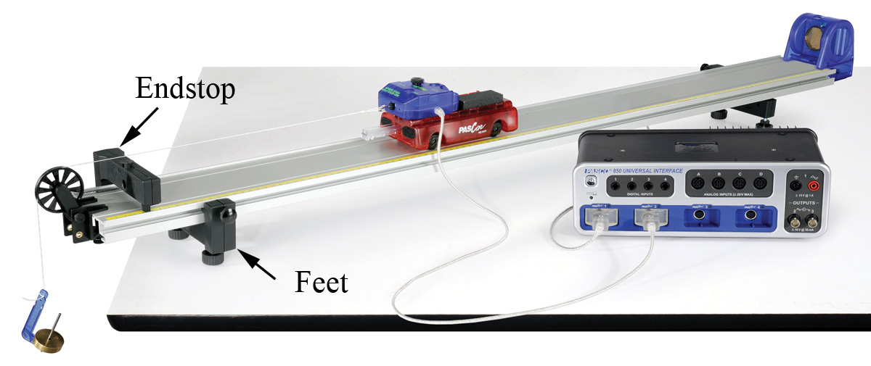

Figure 1. Measuring Force and AccelerationSetup

1. Set up the track as shown in Figure 1, including feet and endstop.
2. Connect the Motion Sensor to the interface, and attach it to the track. Adjust the alignment knob on the side of the Motion Sensor so that it points parallel to the track. Make sure the switch on the top of the Motion Sensor is set to "cart."
3. Connect the Force Sensor to the interface. In PASCO Capstone, set the sampling rate for the Force Sensor to 100 Hz and set the Motion Sensor to 50 Hz.
4. Create a graph of Velocity vs. Time. Add a plot area and select Force on the vertical axis.
5. Using the long thumbscrew, attach the Force Sensor to the cart. Make sure the plunger (see Fig. 2) on the cart is out before attaching the Force Sensor.
6. Place the Cart/Force Sensor assembly on the track. You can increase the mass using the Compact Cart Masses.
7. Make sure the pulley is connected to the clamp using the upper set of holes (see Fig. 3). Clamp the pulley to the end of the track, and place this end over the edge of the table.
8. Use the adjustable feet on both ends to level the track. It is easiest to use a spirit level, but you can also use the motion of the cart.
9. Tie a loop in one end of a one meter length of string. Hang a mass hanger from the loop. Add 15 g to the hanger for a total of 20 g (including the 5 g hanger.) Tie a loop in the other end of the string and attach the loop to the hook of the Force Sensor. Hang the mass hanger over the pulley. Adjust the string so the mass is just above the floor when the cart plunger strikes the endstop.
10. Level (eyeball it) the string by adjusting the pulley. The string must clear the top of the endstop.

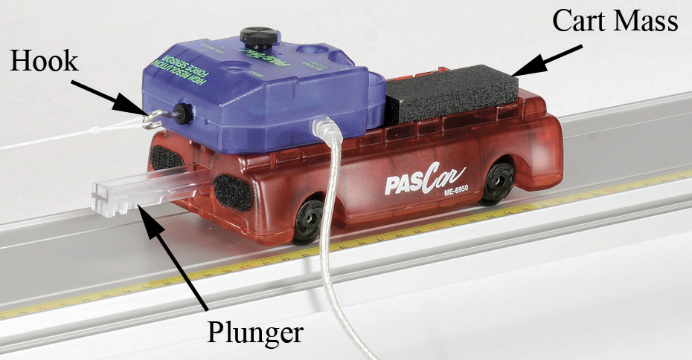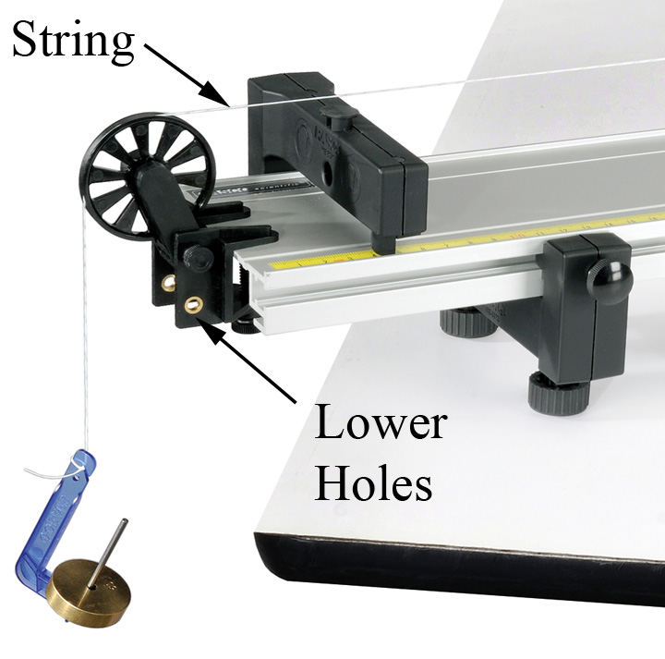

Figure 2. Cart Figure 3. Pulley

Procedure

1. Remove the string from the Force Sensor hook and press the "ZERO" button on the Force Sensor. Then replace the string.
2. Pull the cart back as far as possible without allowing the mass hanger to contact the pulley. Click on Record and release the cart.
3. Make sure the Force Sensor cord does not impede the cart’s motion. To do this, hold the cord with your hand at least 30 cm above the cart and keep your hand directly above the cart as it moves so the cord does not push or pull on the cart.
4. Click STOP after the cart strikes the endstop. If you see noise spikes in your velocity data, try adjusting the angle of the Motion Sensor and moving all objects away from the track including yourself. You can delete unwanted runs using the Delete Run feature in the Control palette at the bottom.
5. When you get a good run, open the Data Summary in the Tool palette at left and re-name this run 20 g.
6. Add 10 g to the mass hanger (now 30 g total), and repeat the procedure to collect data for the 30 g run.
7. Repeat for 40 g, 50 g, and 60 g.

Analysis – Force Data

1. Click the Run Select tool (in the graph), and select the “20 g" run.
2. The Statistics tool (in Graph toolbar) should be turned on, displaying the Mean (average) value on the graph. You can use the Highlight Tool (in Graph toolbar) to select the range over which the average is calculated.
3. Create a table with a User-Entered set called Mass (in grams) in the first column and a User-Entered set called F (in Newtons) in the second column. Enter 20, 40, 50, and 60 into the Mass column. Record the Mean force value in a table. Ignore the sign.
4. Repeat for the other values.

Note: The force, F, is measured directly by the Force Sensor. Since the cart is accelerating, this force is NOT simply the weight of the hanging mass.

Velocity Data

1. Make a graph of v vs. t. Click the Run Select tool and select the “20 g" run.
2. Select a Linear curve fit. You can use the Selection tool to restrict the range over which the average is calculated.
3. What is the physical meaning of the slope? Does it have units?
4. Add a column to the table and create a User-Entered set called “a” with units of m/s2. Record the acceleration in the table. Repeat for the other mass values.

F vs. Acceleration

1. Make a graph the User-Entered set F vs. the User-Entered set “a”. What physical property does the slope of a Force vs. Acceleration graph represent? Hint: what are the units of the slope?
2. Select a Linear curve fit and determine the slope. How well does your slopes match what you should expect? Use the mass balance to measure the actual mass of the Cart + Force Sensor and compare.
3. The graph shows that the applied force is directly proportional to the resulting acceleration. Write the equation in the form F = (?) a
4. What is the name of this equation?